Automated Toll Collection and Theft Detection
using RFID and Image Processing

Capstone Project Report
Mid-Semester Evaluation

Submitted by:
(101603309) Sehajbir Singh
(101603312) Shervil Gupta
(101603316) Shivam Mittal
(101783039) Shivam Bhushan

BE Pre-Final Year, COE
CPG No: 63

Under the Mentorship of
Dr. Deepshikha Tiwari
Assistant Professor


Department
of
Computer Science and Engineering
Thapar Institute of Engineering and Technology, Patiala
May 2019
ABSTRACT

Today, due to the increase in the vehicles, there is a lot of gathering of the traffic at the toll booths. The main reason for this traffic at the toll booths is due to the manual working of the toll tax collection at the booths. Each vehicle on an average need to stop at the tool booth for about a minute for the payment of the toll tax. In order to reduce the traffic jam, to save time, to reduce the money loss of 300 crores/year and theft detection, we have designed a project for the automation in toll tax payment and theft detection using RFID and Image Processing. We have made the automation of toll plaza using combination of microcontroller, RFID and high definition cameras. This will increase the speed of the passing by vehicles allowing them to pass through the booth without stopping, will reduce the manual work and as a result reducing the traffic gathering at the toll collecting booths and also it will help to detect the stolen vehicle as reported to the authorities.
DECLARATION

We hereby declare that the design principles and working prototype model of the project entitled Automated Toll Collection and Theft Detection using RFID and Image Processing is an authentic record of our own work carried out in the Computer Science and Engineering Department, TIET, Patiala, under the guidance of Dr. Deepshikha Tiwari during 6th semester (2019).

Date: 25 May 2019

Roll No. | Name | Signature
101603309 | Sehajbir Singh
101603312 | Shervil Gupta
101603316 | Shivam Mittal
101783039 | Shivam Bhushan

Dr. Deepshikha Tiwari
Assistant Professor
CSED
TIET, Patiala

ACKNOWLEDGEMENT

We would like to express our thanks to our mentor Dr. Deepshikha Tiwari. She has been of great help in our venture, and an indispensable resource of technical knowledge. She is truly an amazing mentor to have.
We are also thankful to Dr. Maninder Singh, Head, Computer Science and Engineering Department, entire faculty and staff of Computer Science and Engineering Department, and also our friends who devoted their valuable time and helped us in all possible ways towards successful completion of this project. We thank all those who have contributed either directly or indirectly towards this project.
Lastly, we would also like to thank our families for their unyielding love and encouragement. They always wanted the best for us and we admire their determination and sacrifice.

Date: 25 May 2019

Roll No. | Name | Signature
101603309 | Sehajbir Singh
101603312 | Shervil Gupta
101603316 | Shivam Mittal
101783039 | Shivam Bhushan

TABLE OF CONTENTS

ABSTRACT ii
DECLARATION iii
ACKNOWLEDGEMENT iv
LIST OF FIGURES vii
LIST OF TABLES viii
LIST OF ABBREVIATIONS ix
CHAPTER 1- INTRODUCTION 10
1.1 PROJECT OVERVIEW 10
1.2 NEED ANALYSIS 12
1.3 RESEARCH GAPS 13
1.4 PROBLEM DEFINITION AND SCOPE 13
1.5 ASSUMPTIONS AND CONSTRAINTS 14
1.6 APPROVED OBJECTIVES 15
1.7 METHODOLOGY USED 16
1.8 PROJECT OUTCOMES AND DELIVERABLES 17
1.9 NOVELTY OF WORK 17
CHAPTER 2 - REQUIREMENT ANALYSIS 18
2.1 LITERATURE SURVEY 18
2.1.1 Theory Associated with Problem Area 18
2.1.2 Existing Systems and Solutions 18
2.1.3 Research Findings for Existing Literature 19
2.1.4 The Problem That Has Been Identified 20
2.1.5 Survey of Tools and Technologies Used 21
2.2 STANDARDS 22
2.3 SOFTWARE REQUIREMENTS SPECIFICATION 23
2.3.1 Introduction 23
2.3.2 Overall Description 24
2.3.3 External Interface Requirements 25
2.3.4 Other Non-functional Requirements 26
2.4 COST ANALYSIS 27
2.5 RISK ANALYSIS 28
CHAPTER 3 – METHODOLOGY ADOPTED 29
3.1 INVESTIGATIVE TECHNIQUES 29
3.2 PROPOSED SOLUTION 29
3.3 WORK BREAKDOWN STRUCTURE 30
3.4 TOOLS AND TECHNOLOGIES USED 31
CHAPTER 4 - DESIGN SPECIFICATIONS 33
4.1 SYSTEM ARCHITECTURE 33
4.2 DESIGN LEVEL DIAGRAMS 34
4.3 USER INTERFACE DIAGRAMS 35
4.4 Snapshots of Working Prototype Model 36
CHAPTER 5: CONCLUSIONS AND FUTURE DIRECTIONS 38
5.1 WORK ACCOMPLISHED 38
5.2 CONCLUSIONS 38
5.3 ENVIRONMENTAL BENEFITS 38
5.4 FUTURE WORK PLAN 39
APPENDIX A: REFERENCES 40

LIST OF TABLES

Table No. | Caption | Page No.
Table 1.1 | Assumptions and Constraints | 14
Table 2.1 | Research findings for existing literature | 19
Table 2.2 | Methods of Feature Extraction from Images | 21
Table 2.3 | Comparative Study of Arduino and Raspberry Pi for their suitability | 21
Table 2.4 | Cost Analysis of hardware components | 27

LIST OF FIGURES

Figure No. | Caption | Page No.
Figure 1.1 | Extraction of Vehicle Identification Number from plates | 16
Figure 1.2 | RFID Architecture | 16
Figure 2.1 | Work plan | 30
Figure 2.2 | Work Break Down Structure | 30
Figure 4.1 | System Architecture of project | 33
Figure 4.2 | System Component Diagram | 33
Figure 4.3 | 3-tier Diagram | 34
Figure 4.4 | State Chart Diagram | 34
Figure 4.5 | Class Diagram | 35
Figure 4.6 | Use Case Diagram | 35
Figure 4.7 | Original license plate image | 36
Figure 4.8 | Extracted license plate | 36
Figure 4.9 | Extracted license plate’s binary image | 36
Figure 4.10 | Final extracted number from license plate | 37

LIST OF ABBREVIATIONS

RFID | Radio Frequency Identification
UHF | Ultra-High Frequency
HD | High Definition
CDMA | Code Division Multiple Access
RTO | Regional Transport Office
SRS | Software Requirement Specification
ATP | Automatic Toll Plaza
OCR | Optical Character Recognition
LAN | Local Area Network
ETC | Electronic Toll Collection System

INTRODUCTION

  - PROJECT OVERVIEW
Our life is changing very fast and the role of automation in our day to day life is increasing at a very fast rate. This is the motive behind our project i.e. “Automation”. Day by day the number of vehicles passing over the road is increasing due to which the road condition is decaying rapidly. The government sponsors the price of road construction and road maintenance. The government has some source of money to build and maintain these roads and this source is the Toll Station.
There is a fear of having vehicles stolen from a common parking lot or from outside owner’s house and it becomes difficult to track down the vehicle. Live location based real time vehicle theft detection and prevention system provide an ultimate solution for this problem. Research has shown that every day 2 vehicles are stolen from a state! That's why it's more important than ever to protect your vehicles with a stolen vehicle recovery system that is reliable and effective.
In today’s era of technology, where machines are being extensively used in all the fields, we are trying to emulate concept, which will be of great use in public transport systems. Today a person has to travel long distances into vastly unknown territories for job, business, or even for tourism. As the vehicles are increasing and roads are falling short, nowadays we see frequently traffic jams or long queues at the toll stations waiting for paying the toll. Paying the toll every-time through cash or checking the pass takes a lot of time. And today Time is more precious than money. Therefore, our project is aimed at reducing time consumed for manual transactions and human effort and it also aims for the ease of theft detection of stolen vehicles by keeping the update of its recent location.
The concept of Toll Station - A toll road, also known as a toll way, is a road for which a driver pays a toll for use [1]. Similarly, there are toll bridges and toll tunnels. Non-toll roads are financed using other sources of revenue, most typically gasoline tax or general tax funds. Tolls have been placed on roads at various times in history, often to generate funds for repayment of toll revenue bonds used to finance constructions and operation. The building or facility where a toll is collected may be called a toll booth, toll plaza, toll station, or toll gate.
1.1.1 Problem Statement
In this era of increased use of vehicles, traffic problems are quite common. Do you ever feel that 10 minutes (or maybe more) could have been reduced from your journey time had there been no congestions at the toll plazas? Due to lack of public awareness, Government efforts and improper implementation of the newly introduced RFID based FASTag system failed to reduce the journey time by any significant amount. This leads to question, what needs to be done for the smooth transit of vehicles through the toll plazas.
A major problem today for car owners is that they are in constant fear of having their vehicles stolen from a common parking lot or from outside their home. Real time vehicle theft detection and prevention system is needed solution for this problem.
1.1.2 Goals
This project aims at solving the traffic congestion problem at the toll plazas by some modifications to the present toll infrastructure and toll deduction methods. The vision and future of this project is to reduce the traffic queues to zero at toll plazas by removing all barriers or speed breakers and still ensuring the correct toll deduction even at normal highway speeds. The secondary aim of this project to provide a Theft Detection System that allows the user to report a vehicle as stolen or missing which would lead the vehicle to be under a radar whenever seen at any toll plaza [7]. This would also be triggered whenever the data retrieved from the vehicle ID plate does not match the data retrieved from RFID tag on the car, meaning obvious tampering to either vehicle ID plate or the RFID tag.
1.1.3 Solutions
The proposed solution is based on a combination of RFID and Image Processing techniques to scan an incoming vehicle through toll with minimal error, without slowing down and automatic toll deduction from the user’s payment wallet. This will be achieved by using UHF RFID sensors and HD Slow Motion Cameras that will scan the incoming vehicle, a Central Database that has information of all the vehicles, their owners and their connected prepaid accounts and a Central Server for all the communications and deductions. This solution aims at providing fast toll deduction within a secure cloud environment [4]. All of the data in the operations performed will be secured with hashes providing no scope of data theft from attackers.
The project is aimed at performing following operations based on the hardware and software technology used: Detection of front and rear Vehicle Identification plates using Optical Character Recognition, RFID sensors to transmit information from the vehicle which is received by the receiver at the plaza. Using the information received from the above sources to connect to the Central server to initialize toll deduction, Using Secure Payment Gateways for transactions, Development of a User Application Panel which provides the user about the information of his recent transactions and Issuing of automatically generated challans to defaulters.
  - NEED ANALYSIS
Traffic Problem at Toll plazas is a very common problem commuters have to face every day. Long queues at Toll Booths lead to wastage of already scarce resources like Fuel. Also, these lead to a delay in Emergency Services like Ambulances, Fire Brigades, etc. The fuel burning in the vehicle engines causes air pollution and wastage of fuel and money. These queues, at some toll plazas, are so long that it takes more than 30 minutes just to cross the plaza. This leads to a serious increase in commute timings between two cities. The Government has been introducing many new policies to counter the “Toll Queue Problem”, which includes the modernized FASTag system and the opening of all toll plazas if any vehicle in the queue has to wait for more than 15 minutes. Both of the mentioned policies have failed either due to technical flaws or improper implementation and thus, we are back to square one. FASTag systems also faces the issue of non FASTag enabled vehicles entering the FASTag dedicated lane, defeating the purpose FASTag was introduced for. So, to overcome the above mentioned “Toll Queue Problem”, some new, more advanced and secure method needs to be introduced, which reduces the queues to zero and ensures all toll deductions automatically without any hassle.
  - RESEARCH GAPS
The technological development aspects of RFID specified above although show that the technology has come a long way but still it needs to importantly focus on reviving the architectural design of an RFID system that has the ability to scale in size according to the changing needs.
Although extensive amount of work has been carried out in the existing literature on RFID anti-collision protocols to improve the performance of RFID systems, but very few empirical investigations have been made in the same context in order to quantify the benefits of the Code Division Multiple Access (CDMA) technology. Apart from that, the data load impact on the identification time of the existing protocols has been found missing in the literature. Thus, it calls for a strong demand to evaluate the impact of data load on the existing RFID anti-collision and propose a new protocol which can identify a greater number of RFID tags than the existing RFID protocols leading to improved RFID system performance but also provides a unique encryption scheme [6].
  - PROBLEM DEFINITION AND SCOPE
The base idea behind implementing RFID Based Toll System is to automate the toll collection process and thereby reducing manual operation in toll booths and the long queues at toll booths using RFID tags installed on the vehicles. In addition to we can not only help the vehicle owners and system administrators from vehicle theft detection but also can track over speeding vehicles, and crossing the signals. Here we are going to see some points regarding to purpose behind choosing this topic & what is the requirement of this type of the project in our day to day life.
- True implementation of Cashless transactions at Toll Plazas.
- Free flow of traffic - Avoid the fuel loss and save time.
- Eliminating any queues on Toll Plazas by completely removing all barriers on the road.
- Auto Generation and dispatch of E-challan to defaulter.
- Avoid financial loss.
- Implementing an effective and fool proof Theft detection and Tampering detection System.
Whenever the matter of Integration of systems comes to mind, we think of a system having the following important features viz.
- Accuracy: All the functionally bonded logical dependencies must be integrated.
- Efficiency: The whole system should work under all circumstances and on a long run it should work efficiently irrespective of their proprietary format.
- Cost Effectiveness: As our software do not require any special software for implementation hence is less costly as compared to other existing system.
- Any Prerequisite for the use: As the existing systems are not altered, and integration is done at the background hence there is no need for any training.
According to the survey of Karnataka Government, in Sept.2012 they have proposed to get the annual toll collection about 2500 crores/year. But in the present situation they are able to collect only 900 crores of the toll value. Means there is loss of 600 crores due to human errors. So, in this situation we have to control this leakage. Now the present system we have with us on the high ways takes 1 minute to complete the toll collection process for one vehicle. With this automatic process, it will take just less than a minute. to complete the whole process. As there is reduction in time for completion of the process so indirectly there will be no traffic as such & as there is no traffic so no fuel wastage takes place & the purpose of designing the highways is achieved i.e. reduction in journey time & also the money loss will be reduced.
  - ASSUMPTIONS AND CONSTRAINTS
Table 1.1: Assumptions and Constraints
S. No. | Assumptions
1 | As this is an automatic deduction system, it is assumed that the user has a bank account and it is linked with the user profile for seamless toll deductions.
2 | The User panel would be provided as a web-based application. So, it is assumed that the user has the basic know how of using the internet and the web-based application
3 | Image Processing works on reading the Vehicle Identification Plate. This is an assumption that the vehicle identification plate is easily recognizable and not damaged beyond recognition. If so, the user will be prompted with a notification about the tampering and asked to get the plate repaired.
4 | This Toll deduction System is based on the combination of Image Processing and RFID system to ensure accuracy. So, it is assumed that the RFID tags are to be made mandatory by the RTO for all vehicles.
5 | The vehicles are assumed to be going at a normal highway speed and not at exceptionally high speed that may lead to dispatch of challan to defaulter for speeding along with toll deduction.

  - APPROVED OBJECTIVES
- Detection of front and rear Vehicle Identification plates using Optical Character Recognition.
- RFID sensors to transmit information from the vehicle which is received by the receiver at the plaza.
- Using the information received from the above sources to connect to the Central server to initialize toll deduction.
- Using Secure Payment Gateways for transactions.
- Development of a User Application Panel which provides the user about the information of his recent transactions.
- Issuing of automatically generated challans to defaulters.
- Ease of maintenance of user database.

  - METHODOLOGY USED
- Image recognition to identify vehicle Identification plates.
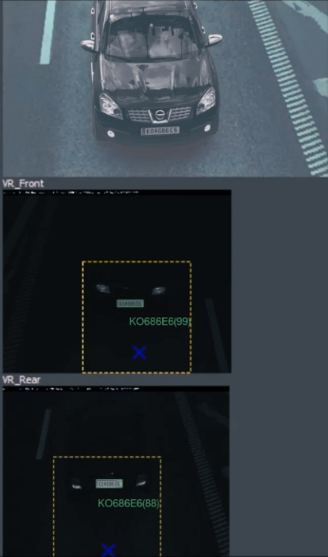

Figure 1.1 Extraction of Vehicle Identification Number from plates
- Radio Frequency Identification System to hold information of vehicle used as a cross reference to the above method.
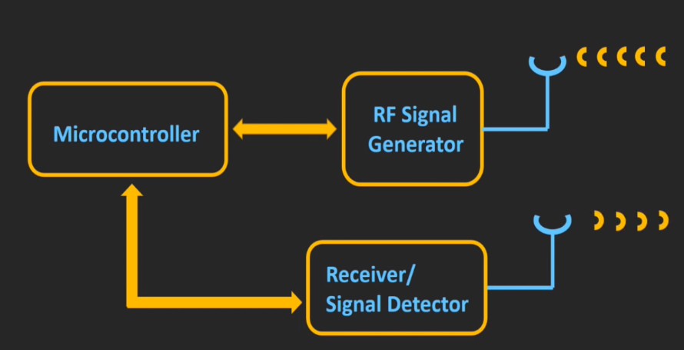

Figure 1.2 RFID Architecture
- Using secure payment gateways to do all the toll deductions automatically.
- Using high end machines for real time processing of data.

  - PROJECT OUTCOMES AND DELIVERABLES
- Faster transit on Toll Roads.
- Cashless Toll Deductions.
- Effective Theft and Tampering Detection.
- Time and Fuel Savings.
- Similar Technologies can be implemented for automated parking systems.
  - NOVELTY OF WORK
This project gives the simplified procedure to passengers to pay toll at toll booths by making them automated, vehicle theft detection, signal breaking avoidance, tracking over speed vehicles. All these activities are carried using single RFID tag thus saving the efforts of carrying money and records manually.
Automatic Toll Collection: The RFID Readers mounted at toll booth will read the prepaid RFID tags fixed on vehicles’ windshield and HD Cameras will check for vehicle identification plate and after cross verification of data from central server, automatically respective amount will be deducted provided no need to stop at the toll booth. If the tag is removed from the windshield i.e. unable to scan the vehicle then cameras fixed at two sites at toll plaza take snaps of the front and back number plate. Since every vehicle registration ID is linked to users account, toll can be deducted from the account bank directly [2]. Also, in case of tampering of vehicle identification plate, e-challans will be generated against the vehicle owner.
Vehicle Theft Detection: When vehicle is stolen the owner registers complaint on the website with its registration ID and unique RFID tag number. Now when stolen vehicle passes by the toll plaza, the tag fixed on it is matched with the stolen vehicle's tag and snapshot of vehicle identification plate using HD cameras will be taken and details will be matched with the database at the toll booth.
Signal Breaking Avoidance: The vehicle ignoring the traffic signal will be detected by the RFID readers fixed at signal crossing and will be notified to the traffic police. This can be done efficiently and great accuracy.
Tracking Over Speeding Vehicle: Vehicle travelling above speed limit can be tracked with 100 % accuracy.
REQUIREMENT ANALYSIS

2.1 LITERATURE SURVEY
Literature Survey is a systematic and thorough search of all types of published literature as well as other sources including dissertation, theses in order to identify as many items as possible that are relevant to a particular topic.
2.1.1 Theory Associated with Problem Area
Human race has surely advanced a lot. Today enjoy numerous facilities without which we cannot imagine our life. These include cell phones, modes of transport and many more. Everyone is becoming more and more dependent on these, especially the transport means. This has been complemented by the recent population explosion and has resulted in more cars and other means of transport than ever. In a modern busy metropolis, traffic congestion is a major hurdle. These congestions at toll collection plazas are usually the main reason of delay on highways, which are otherwise supposed to provide quick transit from one place to other. They create more than one problem, major ones being wastage of time and resources.
2.1.2 Existing Systems and Solutions
Currently there are two ways toll collection is going on at the toll plazas. First is the traditional manual collection of toll tax, where the driver drives up to a designated collection booth made on road, pays in cash and collects the receipt. This method is way too time consuming and requires unnecessary human labor.
The Second method is the recently introduced FASTag system. FASTag is an electronic toll collection system in India, operated by the National Highway Authority of India (NHAI). It employs Radio Frequency Identification (RFID) technology for making toll payments directly from the prepaid or savings account linked to it. It is affixed on the windscreen of the vehicle and enables to drive through toll plazas without stopping for transactions. The tag can be purchased from official Tag issuers or participating Banks and if it is linked to a prepaid account, then recharging or top-up can be as per requirement. This system was a way better way of toll collection as this minimized the waiting time and also mostly eliminated the human requirement. This system, however has its flaws. It is highly reliant on the user’s car having an installed FASTag installed and having sufficient balance in the account (or wallet) connected to the FASTag.
These are appreciable attempts to solve the problem of toll collection and congestion at toll plazas. We are attempting to improve its efficiency and make it applicable universally, that is to all vehicles, irrespective of them having a FASTag installed or not.
2.1.3 Research Findings for Existing Literature
Table 2.1: Research findings for existing literature
Sr. No. | Paper Title | Tools / Technology | Findings | Citation
1 | Unobtrusive long-range detection of passive RFID tag motion | Passive RFID tags | Passive RFID tags are suitable for many purposes like toll collection, supply-chain management | Bing Jiang et. al. [3]
2 | RFID Security and Privacy:  A Research Survey | Privacy and Security of RFID using various cryptographic approaches | A minimalist system in which every tag contains a small collection of pseudonyms; it rotates these pseudonyms, releasing a different one on each reader query. | Ari Juels et. al. [3]
3 | An Overview of the Tesseract OCR Engine | Tesseract OCR Engine | Using Tesseract OCR Engine to read from images, which may have data in curved baselines | R. Smith et. al. [5]
4 | Automatic License Plate Recognition | Color edge detection,  Character Segmentation,  Character Recognition | License plate locating module characterized by fuzzy disciplines attempt to extract license plates from an input image and license number identification module conceptualized in terms of neural subjects aims to  identify the number present in a license plate. | Shyang-Lih Chang
5 | License Plate Recognition from Still Images and  Video Sequences: A Survey | License Plate Detection using Image Manipulation and Recognition of character using classifiers | License plate recognition in images  or videos are composed of 1) extraction of a license plate region; 2) segmentation of  the plate characters; and 3) recognition of each character | Christos-Nikolaos E. Anagnostopoulos

2.1.4 The Problem That Has Been Identified
Many attempts have been made by the government and researchers to develop a system that is efficient and accurate enough to eliminate (or minimize) the congestion at toll plazas. Many government policies have been drawn that define the working of toll plazas to minimize the waiting time at toll collection plazas. Despite being successful in reducing the traffic problem to a certain degree, the problem still exits and hasn’t been eliminated completely. We are trying to improve this system to assist in the quicker transit of vehicles on Highways with minimum waiting time at toll plazas.
Objective is to develop a special RFID and Image Processing coupled toll collection system that can identify all vehicles with the data retrieved from RFID technology from the installed RFID tags and Image Processing Algorithms that process the vehicle identification plated and retrieve information based on the processed image. Through this we aim to achieve a better efficiency and accuracy than the existing solutions.

2.1.5 Survey of Tools and Technologies Used
Table 2.2: Methods of Feature Extraction from Images
S. No. | Methodology | Reference | Description
1. | Feature Extraction methods for character recognition | ØivindDue Trier, Anil K. Jain, Torfinn Taxt  (Feature extraction methods for character recognition-A survey) | Extraction of features from

Table 2.3: Comparative Study of Arduino and Raspberry Pi for their suitability
Parameters | Arduino Uno | Raspberry Pi B+
What it is | A microcontroller board | A general-purpose computer
Ease of Use | Very easy | Complicated
Processor | ATMega328P | Quad-core ARM Cortex A53
Used for | Simple repetitive tasks, driving simple robots. Not suitable for multiple tasks. | Requirement is full-fledged computer, performing complicated tasks like intensive calculations.
Clock speed | 16 MHz | 1.2GHz
Communication supported | IEEE 802.11 b/g/n  IEEE 802.15.4 433RF BLE 4.0 via Shield | IEEE 802.11 b/g/n IEEE 802.15.4 433RF  BLE 4.0Ethernet Serial
Development environments | Arduino IDE | Linux Operating Systems
Clearly the Raspberry Pi B+ is well suited for our needs and is an obvious winner.
2.2 STANDARDS
Code Standard
- Our code is conformed to PEP 8, the Style Guide for Python Code.
- The code layout and white-space, comments, imports, documentation strings, version book keeping, programming recommendations, and naming conventions is conformed to PEP 8.
- We have also used a few deviations from the Basic Standard.
Safety Standard
- ISO 13849 safety standard has been followed.
- It deals with safety of machinery, safety related design principles of control systems.
Software Process Quality Standard
- ISO/IEC 15504, also known as Software Process Improvement and Capability Determination (SPICE), is a set of technical standards documents for the computer software development process.
- This standard is gone for setting clear model for process correlation. It shows procedures to oversee, control, guide and screen programming improvement. This model is then used to gauge what a task group really does amid programming improvement. This data is dissected to recognize shortcomings and drive enhancement.
Communication Standard
- 802.15.1, also termed as Bluetooth, is used for communicating wirelessly between prototype buggy and the computer.
- Proprietary wireless: 2.4GHz band.
- It is a remote systems administration standard which has low-information rate and devours low-control which goes for supplanting links between lightweight gadgets.
2.3 SOFTWARE REQUIREMENT SPECIFICATION
2.3.1 Introduction
The SRS document aims at providing a detailed overview of the final deliverable product, its parameters and goals.
2.3.1.1 Purpose
The base idea behind implementing RFID Based Toll System is to automate the toll collection process and thereby reducing manual operation in toll booths and the long queues at toll booths using RFID tags installed on the vehicles. In addition to we can not only help the vehicle owners and system administrators from vehicle theft detection but also can track over speeding vehicles, and crossing the signals. Here we are going to see some points regarding to purpose behind choosing this topic & what is the requirement of this type of the project in our day to day life.
- Avoid the fuel loss.
- Saving of time in collecting toll.
- Avoid financial loss.
- To monitor the traffic.
2.3.1.2 Intended Audience and Reading Suggestions
Now a days there is a huge rush in the toll plazas in order to pay the toll tax. Therefore, in order to reduce the traffic jam and to save the travelers’ time, & also to reduce the money loss of 300 cores/year approximately, we have designed project for the automation in toll tax payment using RFID. We have made the automation of toll plaza using combination of microcontroller, RFID.
2.3.1.3 Project Scope
This report explains the implantation of automation in toll plaza which is a step towards improving the monitoring of vehicles, travelling in predetermine routes. The aim of our project is to design a system, which automatically identifies an approaching vehicles and record vehicles number and time. If the vehicle belongs to the authorized person, it automatically opens the toll gate and a predetermined amount is automatically deducted from its account. This translate to reduced Traffic congestion at toll plazas and helps in lower fuel consumption. This is very important advantage of this system.
2.3.2 Overall Description
As we all know that transportation is the backbone of any country’s economy. Improvement in transportation systems result into the good lifestyle in which we achieve extraordinary freedom for movement, immense trade in manufactured goods and services, as well as higher rate of employment levels and social mobility. In fact, the economic condition of a nation has been closely related to efficient ways of transportation. Increasing number of vehicles on the road, result into number of problems such as congestion, accident rate, air pollution and many other. The proposed solution is based on a combination of RFID and Image Processing techniques to scan an incoming vehicle through toll with minimal error, without slowing down and automatic toll deduction from the user’s payment wallet. This will be achieved by using UHF RFID sensors and HD Slow Motion Cameras that will scan the incoming vehicle, a Central Database that has information of all the vehicles, their owners and their connected prepaid accounts and a Central Server for all the communications and deductions. This solution aims at providing fast toll deduction within a secure cloud environment. All of the data in the operations performed will be secured with hashes providing no scope of data theft from attackers.
2.3.2.1 Product Perspective
The world is running faster than ever imagined. People are in a constant haste. Time is becoming as crucial an entity as money. From top businesses to a common man, everyone wants to save time. And our project aims to do exactly what they want. As it is studied by researchers and also applied in various expressways, bridges, and tunnels require such a process of Automatic Toll Plaza. ATP is capable of determining if the vehicle is registered or not, and then informing the management center about to process violations, debits, and participating accounts. The most excellent advantage of this ATP system is that it is capable of eliminate congestion in toll plaza, especially during those seasons when traffic seems to be higher than normal.
2.3.2.2 Product Features
- Should ensure Shorter queues at toll plazas by increasing toll booth service rates.
- Should offer Faster and more efficient service
- Should have the ability to make payments by keeping a balance on the card itself
- The facility of postpaid toll statements should be present.
- Other general features include minimization of fuel wastage and reduced emissions by reducing deceleration rate, waiting time of vehicles in queue, and acceleration.
2.3.3 External Interface Requirements
The various interfaces requirements are as follows:
2.3.3.1 User Interfaces
In this we do not require any user interface. Once the RFID tag has been placed in proper location on the windshield, it will automatically be detected by the RFID readers deployed at the toll plazas.
2.3.3.2 Hardware Interfaces
The system will consist of major 3 hardware, one is RFID tag and the other one is RFID reader and slow-motion cameras. The RFID tag will be placed on the windshield of the vehicle, and the readers will be deployed at the various Toll Plaza. As the Tag comes in range of reader, the reader reads the information encrypted on the tag, and will send it to the software interfaces for the further processing. The camera will capture an image of the vehicle passing, and will send it further to software interfaces for other processing.
2.3.3.3 Software Interfaces
The software interfaces required here will be a microcontroller which will send the data to processing unit. The data gathered from the RFID reader as well as Camera will be processed here. The data will be used to verify that no tampering has been done and also to check if this is not a fraud case.
2.3.4 Other Non-functional Requirements
The non-functional requirements are as follows:
      - Performance Requirements
- Usability: It should be easy enough to set up, as it has to be used by all type of people.
- Testability: Every system is required to be tested for any flaws or bugs before handing it to the customers
- Maintainability: The RFID tag is available separately, but it has to be linked with the car details. Therefore, not very easy to replace in case it wears off.
- Extensibility: The technology can be extended to use in large number of applications like theft detection etc.
2.3.4.2 Safety Requirements
- The system should reflect back correct data to RFID reader.
- Camera should capture image at correct time so that licence plate can extracted easily from it.
2.3.4.3 Security Requirements
- The data transmitted by the RDIF tag should not be captured by 3rd person in middle.
- The payment portal has to be extreme secure and fast so as to handle large number of transactions.
  - COST ANALYSIS

Table 2.4: Cost Analysis of hardware components
Sr. No. | Device | Function | Cost
1 | Raspberry PI 3 Model B+ Motherboard | Processing Unit for all computations and for connections to central operational database | Rs. 2990
2 | Raspberry Pi 3 Case | Protective Case for the Raspberry Pi Motherboard to protect it from damages in handling | Rs. 250
3 | Raspberry Pi 8 MP NOIR Camera Module | NOIR Camera Module of Raspberry Pi 3 to capture images in daytime as well as at night for processing | Rs 2000
4 | 32 GB MicroSDHC card | Storage media for installing of Operating System and Application Software of Raspberry Pi | Rs 450
5 | UHF RFID Tags | RFID tags to store information and share them upon receiving a suitable radio frequency | Rs 450
6 | 125K Long range Reader Module EM4100 | RFID Transceiver to read data from a RFID tag from a long range | Rs 2300
 | Total |  | Rs 8440
  - RISK ANALYSIS
- Our project processes stream line of input data received and transmitted via various hardware components. If there is any case where hardware components are hampered or are unable to provide accurate inputs due to any unforeseen reasons, further operations that require previous data as an input will be hampered too.
- If the cameras that are used to take the input data are providing manipulated or low-quality image inputs due to some external reason or any technical issue that may occur, efficiency is not guaranteed.
- There maybe also a case where the calculated results are not idle or correct even when the input provided is accurate. The microcontroller may not function properly and may signal wrong output.
- High latency in time calculation may lead to inefficient activity.
- There may be a chance of spoofing of identity. For e.g. any unauthorized personnel may interact with the functionality provided for manual operations. Although the odds are very less but in case of such unprecedented activity the normal functionality of the installed system may not be obtained.

METHODOLOGY USED

3.1 INVESTIGATIVE TECHNIQUES
According to the mentioned above techniques this project uses the descriptive technique of the investigative techniques this is because as mentioned in the descriptive technique the new models, concepts and systems are designed.
3.2 PROPOSED SOLUTION
Whenever any person buys a vehicle, first he/she needs to do her vehicle registered at the RTO office. RTO people will assign a number plate to it along with it they will give a RFID enabled tag. This card will have a unique ID to use with that vehicle only. They will also create an account for that particular prepaid card and maintain transaction history in database. Owner of the vehicle needs to deposit some minimum amount to this account.
Every time a registered vehicle approaches the toll booth, first the RFID reader will detect the presence of the vehicle which in turn activate the RFID circuit to read the RFID enable card fixed on the vehicle. HD Camera will click the snapshots of the front and rear Vehicle Identification Plate without the stopping of the vehicle and send the numbers extracted using image processing to the operation unit. At this point, toll will be deducted only if the data from both RFID and Cameras matches otherwise a case of tampering. Transaction will begin, depending upon the balance available toll will be deducted directly or a challan will be generated against the owner. The software further updates the details in the centralized database server.
It also sends SMS with the bill information and will be sent to user as a text message using GSM module. On the other hand, whenever any vehicle owner registers a complaint at the RTO office regarding theft of the vehicle respective entry is made in the database. Now any vehicle arriving at toll booth with same ID as already present in stolen vehicle category will be easily identified as the ID assigned with it is unique. All the toll plazas will be connected to each other along with the centralized server in the form of LAN. Updates of any sort of transaction will be immediately updated to local database and centralized server
3.3 WORK BREAKDOWN STRUCTURE
A work breakdown structure in undertaking administration and frameworks designing is a deliverable-situated breakdown of a venture into little parts. A work breakdown structure is a key venture deliverable that arranges the collaboration into sensible areas. The Project Management Body of Knowledge (PMBOK) characterizes the work breakdown structure as a "deliverable arranged progressive disintegration of the work to be executed by the undertaking group." Breaking the complex structure into simpler items over the duration of the project.
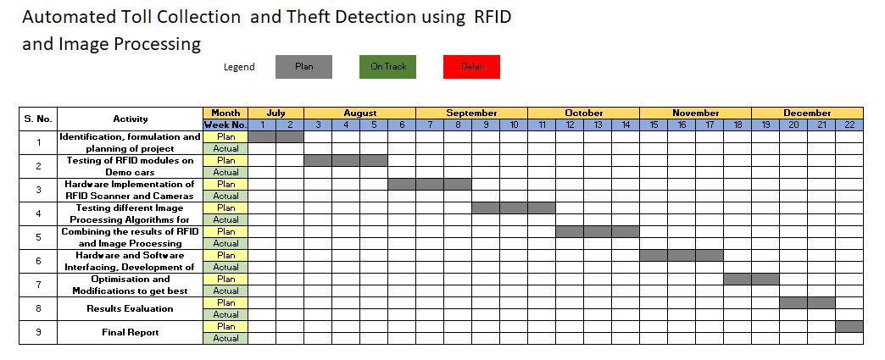
Figure 2.1: Work plan
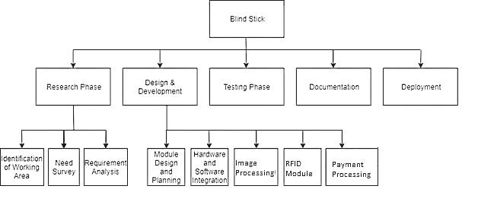
Figure 2.2: Work Break Down Structure
  - TOOLS AND TECHNOLOGIES USED
- Radio Frequency Identification (RFID) Technique - Radio Frequency Identification (RFID) is an automated data capture technology that can be used to electronically identify, track, and store information contained on a tag that is attached to or embedded in an object. RFID-silicon-based electronic identification tags, consisting of a tiny processor, memory, antenna. RFID tags can be read and written wirelessly and can be made cheap, without a battery.
- Optical Character Recognition (OCR) Technique - Optical Character Recognition (OCR) is widely used technology which converts scanned images of printed text, handwritten text characters into machine encoded text information such as ASCII. It can be recognized printed characters and handwritten characters but the performance is directly dependent from the quality of input documents.
- Image Processing Technique - Image processing consists of several stages: image import, analysis, manipulation and image output. There are two methods of image processing: digital and analogue. Computer algorithms play a crucial role in digital image processing. Developers use multiple algorithms to solve different tasks, including digital image detection, analysis, reconstruction, restoration, image data compression, image enhancement, image estimation and image spectral estimation.
- Slow Motion High Definition Cameras - Capturing the vehicle’s vehicle identification plate in slow motion requires a sophisticated camera that can capture a high number of frames per second with a respective resolution. Slow motion cameras allow you to capture vehicle’s vehicle identification plate as it enters int the range of toll booth.
- Raspberry Pi (or similar single board computer) - The Raspberry Pi is a low cost, credit-card sized computer that plugs into a computer monitor or TV, and uses a standard keyboard and mouse. It is a capable little device that enables people of all ages to explore computing resources. Raspberry pi will help in the computation of algorithms needed to accomplish this project.
- Web and Mobile Portal – Exploring the user interface designs of our project using CSS, JavaScript and Android etc. Working with python to for the operations of backend.
DESIGN SPECIFICATIONS

4.1 SYSTEM ARCHITECTURE
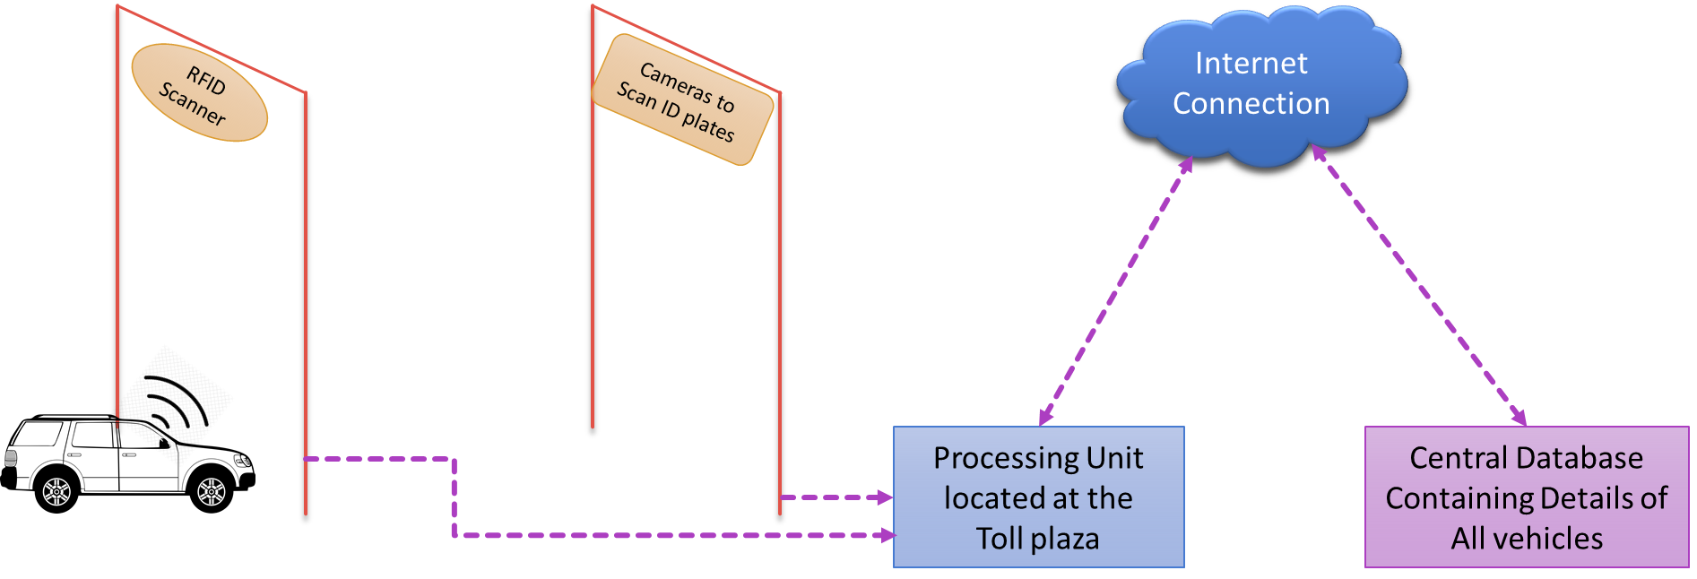
Figure 4.1: System Architecture of project

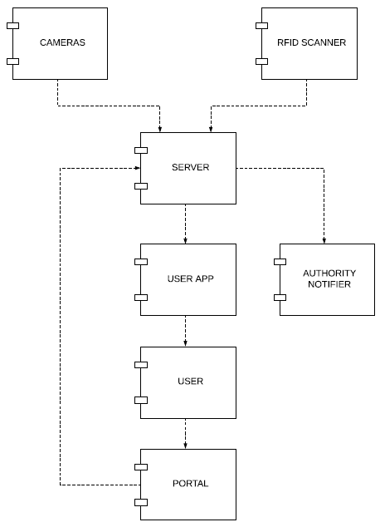
Figure 4.2: System Component Diagram
4.2 DESIGN LEVEL DIAGRAMS

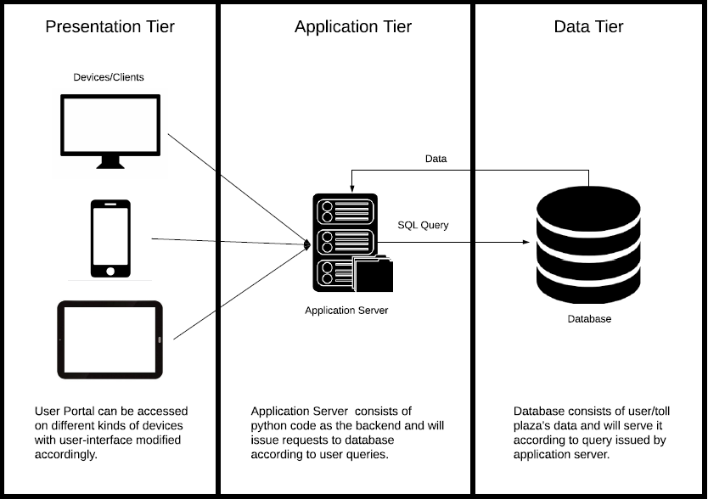
Figure 4.3: 3-tier Diagram

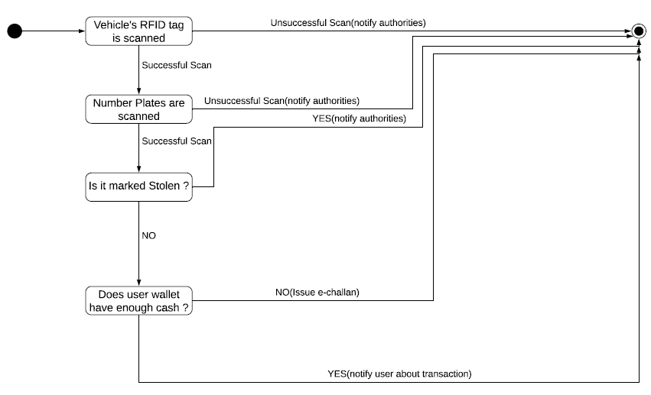
Figure 4.4: State Chart Diagram

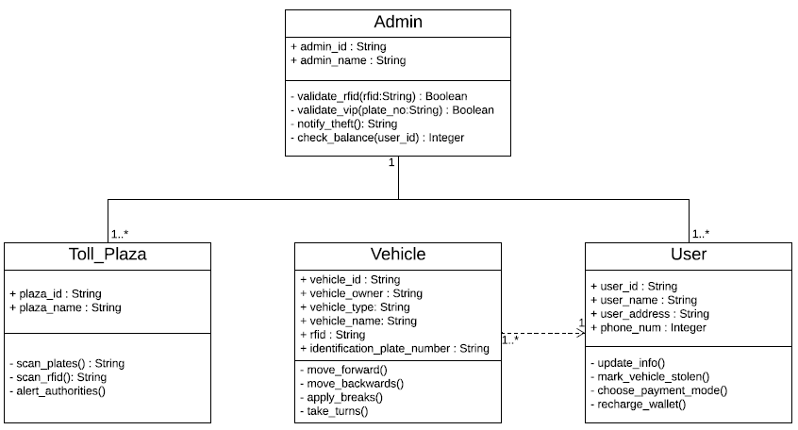
Figure 4.5: Class Diagram

4.3 USER INTERFACE DIAGRAMS
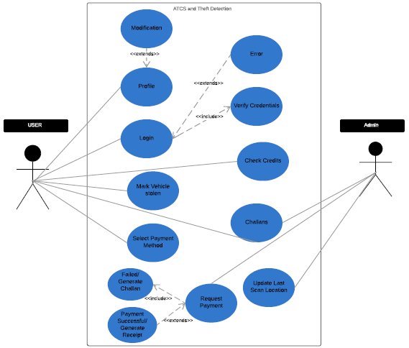
Figure 4.6: Use Case Diagram
4.4 Snapshots of Working Prototype Model

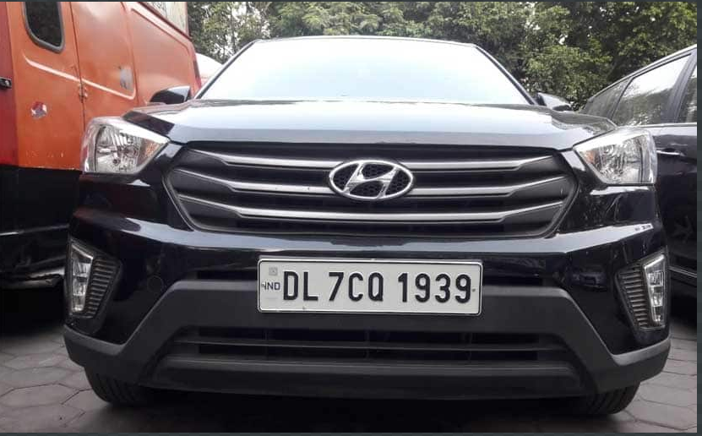
Figure 4.7: Original license plate mage

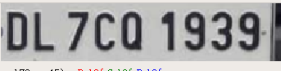
Figure 4.8: Extracted license plate


Figure 4.9: Extracted license plate’s binary image

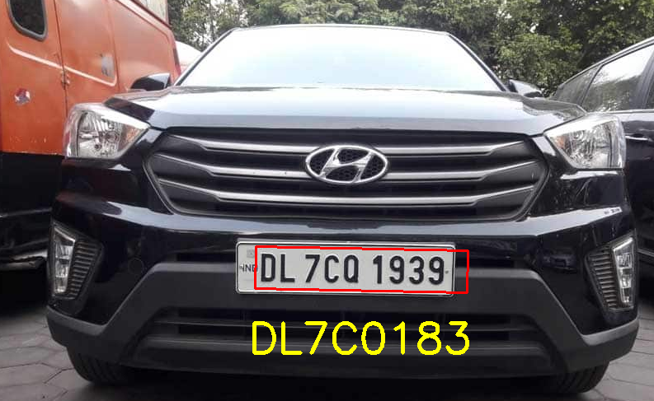
Figure 4.10: Final extracted number from license plate

CONCLUSIONS AND FUTURE DIRECTIONS

5.1 WORK ACCOMPLISHED
Till now the model is finished with one module which contain the code and output for an image of vehicle license plate. Code for number extraction is implemented in python. Still, working on the RFID module to increase its efficiency for smooth scanning.
5.2 CONCLUSIONS
The Electronic Toll Collection system in expressway based on RFID, a design scheme was put forward. It is low cost, high security, far communication and efficiency, etc. It not improves the passage ability of expressway but also improve the technology level of charge. Electronic toll collection system using RFID is an effective measure to reduce management costs and fees, at the same time, greatly reduce noise and pollutant emission of toll station. In the design of the proposed Electronic toll collection (ETC) system, real time toll collection and anti-theft solution system have been designed. This reduces the manual labor and delays that often occur on roads. This system of collecting tolls is ecofriendly and also results in increased toll lane capacity. Also, an anti-theft solution system module which prevents passing of any defaulter vehicle is implemented, thus assuring security on the roadways.
5.3 ENVIRONMENTAL, ECONOMICAL AND SOCIAL BENEFITS
- Implementation of Automatic Toll System has reduced air pollution and use of paper.
- There’s a drastic change in the toll plazas, as toll payment hassles are minimized and highway management system has improved.
- The Automatic Toll System has also reduced the efforts in managing the toll plazas.
- While the Automatic Toll System has many positive sides, it also has its drawbacks. It will come as a complete winner only if these flaws are sorted as soon as possible.
- A special lane dedicated for Automatic Toll System users means it saves time.
- The non-stop vehicular movement means lower fuel cost.
- A user can sign up on the online portal and use it to recharge, lodge complaint or check what’s latest.
- There is a provision to alert the users through SMS about their toll transactions, low balance, etc.
5.4 FUTURE WORK PLAN
- To ease the mode of payment - transactions and recharge of vouchers, net banking of almost all banks can be integrated as a part of the project.
- The project can also be extended to possessing greater automated location tracking capability also opt the same for automated parking systems.
- The project can be secured against impersonation (exchange of tags) by incorporating decision recognition application that serve to increase security at the booth

REFERENCES

[1] Sachin Bhosale,Dnyaneshwar Natha Wavhal. “Automated Toll Plaza System using RFID” IJSETR, Vol 2,Issue 1, Jan 2013.

[2] Janani SP, Meena S, Automatised Toll Gate System Using Passive RFID and GSM Technology, Vol. 5. Issue ECIA2012-3 Journal of Computer Applications, February 10,2012.

[3] Asif Ali Laghari, M. Sulleman Memon and Agha Sheraz Pathan, “RFID Based Toll Deduction System,”I.J. Information Technology and Computer Science, 2012, 4, 40-46

[4] Aniruddha Kumawat, Kshitija Chandramore, “Automation Toll Collection System Using RFID”, Vol. 2, Issue 2, April-June 2014

[5] Asif Ali Laghari, M. Sulleman Memon, Agha Sheraz Pathan, “RFID Based Toll Deduction System”, I.J. Information Technology and Computer Science, April, 2012

[6] Janani S P, Meena S, ”Automatised Toll Gate System Using Passive RFID and GSM Technology”, Journal of Computer Applications, Vol. 5, Issue 12-3, February 10, 2012

[7] Pranoti salunke, Poonam Malle, Kirti Datir, Jayshree Daluke, “Automated Toll Collection System and Theft Detection Using RFID” IOSR Journal of Computer Engineering (IOSR-JCE), Vol 9 Issue 2, Feb 2013

[8] AungMyint Win, Chaw MyatNwe, KyawZinLatt, “RFID Based Automated Toll Collection Plaza”, International Journal of Scientific and Research Publications, Volume 4, Issue 6, June 2014

http://www.nyu.edu/projects/jerschow/pubs.html

http://www.ewek.com/category

http://www.ftc.gov

http://www.rfidjournal.com

